A Cultural Landscape Approach
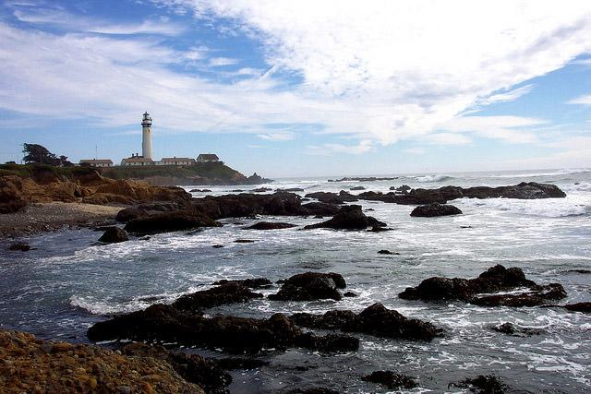Lighthouse - Half Moon Bay, CA
One Place – Many Values
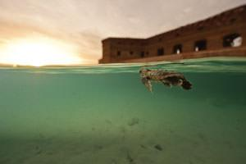Sea turtle at Dry Tortugas
Often, sites selected as MPAs have been important to people for decades, centuries, or even millennia. The biological richness or other location attributes made them essential to different cultures and many stakeholder groups. Cultural heritage and resources reflect long-standing and contemporary human connections and uses of marine areas. In revealing our common dependence on marine places, cultural heritage also reveals individual connections to specific cultures, peoples, and spaces. The integration of cultural and natural heritage creates opportunities to recognize and value cultural and social differences, while embracing a broad shared vision of stewardship for the marine environment.
Meeting Obligations
Identifying and protecting particular kinds of cultural resources is a legal obligation as well as an agency mandate. Meeting these obligations depends on many factors and is subject to different interpretations by individuals, organizations, and courts. The managers of MPAs are the front line stewards for special places held in trust for the public good. Charged with maximizing the protective and social benefits of MPAs, managers of marine cultural and natural heritage resources deal with complex technical, ethical, and moral questions and challenges. Creating Opportunities
Integrating cultural heritage provides dynamic opportunities for improving MPA outcomes. The Cultural Landscape Approach that provides the ethical and intellectual foundations for this toolkit offers fundamental principles that can guide MPA planning and management throughout the United States and its protectorate areas. Cultural heritage provides a well-tested means for expanding community engagement. Using a Cultural Landscape Approach to link biophysical science with historical, ethnohistorical, ethnographic, archaeological, place-based traditional and stakeholder knowledge and insights offers a clear path toward successful ecosystem-based management and broad-based community stewardship.
An Evolving Discipline
Despite origins that date back to the 1970s, the field of Maritime Cultural Landscapes is still an emerging one. Maritime Cultural Landscapes effectively apply the CLA to marine environments and maritime cultures.
Read more about a Cultural Landscape Approach in the National MPA System.
Read more about a Maritime Cultural Landscape approach.

What are Cultural Resources?

Below are examples of cultural resources that may be found in an MPA. These categories are not mutually exclusive and may overlap. Resources may be nautical (related to ships, vessels and watercraft), maritime (related to human seafaring) or cultural (related to cultural identity, such as religious, food and burial practices). A cultural landscape approach is a useful framework for understanding how cultural and environmental resources overlap and influence one another.

Maritime cultural resources
- Shipwrecks (e.g. USS Monitor) and sunken boats, large and small
- Airplanes and other wrecks of craft in the marine environment (e.g. the airship USS Macon and spacecraft artifacts off Cape Canaveral)
- Submerged land vehicles (e.g. amphibious vehicles, tanks, trucks)
- Inundated, sunken or eroding coastal structures such as lighthouses, forts, coastal defense structures, life saving stations, buildings, ports, and towns (e.g., sunken city of Port Royal, Jamaica)
- Submerged portions of docks and wharves
- Bridges
- Stories and history about a place or group’s maritime connection to the sea
- Landings used by ferries and boats

Indigenous cultural resources
- Traditional fish ponds (e.g. in Hawaii)
- Submerged cultural sites (e.g. occupation sites of indigenous ancestors, middens)
- Sunken/buried indigenous watercraft (e.g., canoes, log boats)
- Fishing weirs / fish traps
- Sites exposed on actively eroding shorelines such as habitations, burials
- Sites with importance religious or spiritual values (e.g. Papahānaumokuākea)
- Living marine resources with important cultural values (e.g. salmon and shellfish in the Pacific Northwest, coral in Papahānaumokuākea and Dugong in Japan)
- Stories and history about the tribe or group and its connection to the sea

Associated land-based resources that may be part of a cultural landscape:
- Coastal forts
- Ports and harbors
- Lighthouses and other navigational aids
- Docks / warehouses / port facilities
- Fish processing plants
- Shell and trash middens
- Whaling stations
Climate Change Adaptation
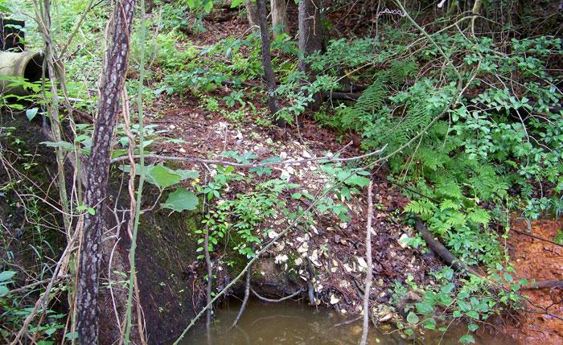A shell midden on the Rappahannock River erodes around a culvert built to divert rain water into the river. This site has never been formally documented. (Leslie Reeder-Myers)

Heritage sites are often the primary resource for understanding how humans responded to past climatic regimes, but are sometimes omitted from plans for mitigating adverse climate impacts. With renewed awareness of how climate change may impact cultural heritage, managers can take proactive steps to minimize the impact of climate change on their resources. Some expected changes include:
- Sea level rise will flood cultural resource sites in coastal floodplains and make other sites more susceptible to damage.
- Increased coastal erosion brought about by higher sea-levels, increased storminess, and greater climatic extremes may expose or inundate heritage resources.
- Changes in temperature and precipitation patterns may require improved infrastructures for enclosed cultural resources, especially historic sites, archives, and museum collections to adapt to hotter, colder, rainier, or more humid weather.
- Increased extreme weather events may cause significant damage to fragile heritage resources due to increased mechanical weathering or direct storm destruction.
- Rising ocean temperatures, changing oceanic circulation, and ocean acidification will have repercussions for communities that rely on marine resource for their heritage and regional identity. Also, altering the range of certain species (e.g. Teredo navalis, which consumes wood) may have devastating consequences for submerged heritage resources such as historic shipwrecks.
Opportunities and Obligations
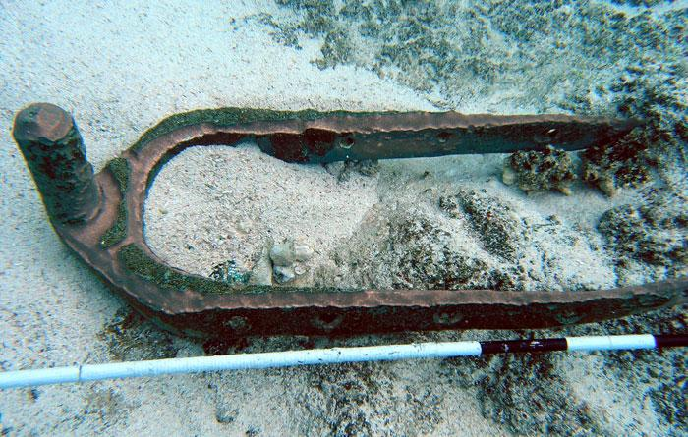This 180-year-old bronze pintle (ship rudder hardware) shows an older dark and grainy accretion surface (buried in sediment), as well as more recent bright sand scour weathering patterns (exposed) due to a changed sediment transport regime. These types of artifacts can be physical records of changing hydrodynamic/sedimentation regimes, changes that can greatly accelerate deterioration. (NOAA ONMS)

Today, climate change threatens to destroy information about how people, past and present, have adapted to changes in their environment. In many societies, traditional knowledge and native language associated with the physical ethnographic resources are not always in written form, and instead are passed from generation to generation through oral tradition and expressive culture, such as song, dance, and music. Without intervention, such attributes may also be at risk of permanent loss because of possible population displacement or loss of the people possessing such knowledge. Resource managers need to consider the implementation of appropriate strategies regarding the protection or preservation of ethnographic resources within the context of climate instability. Moreover, such resources may serve as indicators of change or clues for protecting key ecological and cultural features within a traditional maritime cultural landscape.
Many historic and prehistoric cultural resources, in addition to their inherent value to the people and cultures connected to them, have scientific value as repositories of historical ecological data. These sites and records tell the stories of the ecological impacts of past peoples, and the ways that societies have adapted to past climate change.
Methods and Approaches
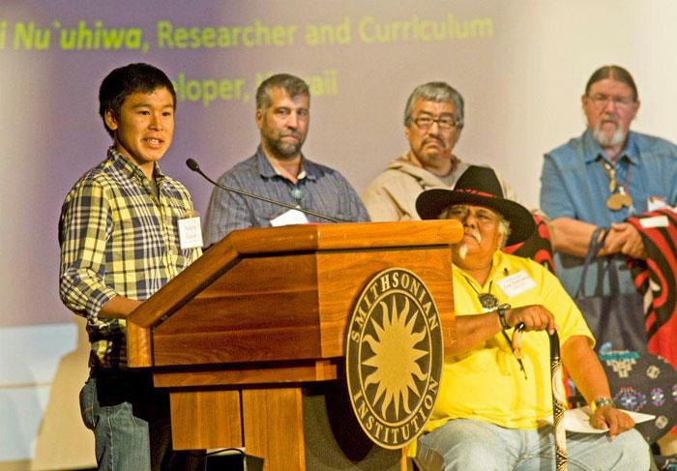The 2012 First Stewards Symposium at the National Museum of the American Indian brought together tribal leaders, tribal and Western scientists, and agency representatives from all US regions who examined how native people and their cultures have adapted to climate change for hundreds to thousands of years, and what their future—and that of America—may hold as the impacts of climate change continue. (NOAA ONMS)

MPA managers may already be following Climate Smart Conservation principles in their management of natural resources. Such steps are highly compatible with managing the ethnographic resources of the MPA, which have cultural value to particular ethnic or social groups. These often include traditional ecological knowledge, resource use, archival data, genealogical information, family history, oral histories.
Other cultural resources, such as archaeological sites, submerged vessels, prehistoric rock art, historic and prehistoric structures, and/or museum collections, are fixed in place and derive much of their significance from the place in which they originated. Most are nonliving and have unique qualities. While their capacity to adapt to changing environments and conditions are limited, managers can implement "no-regret" strategies to minimize climate change impact.
Scenario planning
Scenario planning offers an approach for long-term strategic planning in situations with uncertainty and risk, in which managers consider a variety of options for the future and develop responses and action plans for each situation. It has been employed in business situations, and is now being used by conservation managers facing uncertain climate change. Scenario planning does not attempt to predict the most likely future but uses "what if" questions to explore a range of plausible multiple working futures and consider appropriate actions within them, including adaptive management strategies.
Vulnerability Assessment and Adaptation Strategies
The first step is to include cultural heritage resources within your own site's resource inventory, and to conduct a vulnerability assessment for heritage resources within your site's planning for climate change. Cultural sites, including ethnographic resources, must be fully documented, with prioritization given to those at high risk. For those identified as vulnerable, managers can work closely with partners to determine the resources' significance while specifying a course of action. These actions may include relocation, protection in place, research before loss, or no action. In many cases, effective strategies have a low cost of implementation and would significantly improve our ability to accommodate future climate changes.
No Regret" Strategies
“No regrets” strategies are those that will benefit the site and potentially other sectors, regardless of climate impacts. These are also strategies that will not divert resources away from other priorities because they have a low to medium cost of implementation. “No regrets” strategies for the protection of cultural heritage resources may apply to the underwater resources within the MPA boundaries, the associated museums, archives, visitor centers, and the cultural knowledge relevant to the MPA.
Examples of these strategies include:
1. Structural Reinforcement
When cost effective, improving the structural stability, water drainage systems, and weather proofing of Cultural Resources sites will extend the lifetime of the site and may improve the functionality of the site.
2. Locate and Record Sites in Vulnerable Areas
Many coastal or recently submerged cultural heritage sites have never been recorded. Surveys, especially at low tide, are a cost effective means of collecting basic information before it is lost.
3. Prioritize Study of Vulnerable Sites
Identifying and focusing research efforts on those historical, archaeological and ethnographically significant sites that are most vulnerable to incurring irreversible damage due to effects associated with climate change should not adversely affect other sites.
4. Maintain and Increase Climate Control Capabilities
Increasing temperature and humidity monitoring capabilities at Museums and Archives, where records pertaining to the MPA's Cultural Heritage are kept, will help maintain archives, and increase year round usage of the site.
5. Maintain and Develop Emergency Management Plans
Most Cultural Resource sites do not have emergency management plans and would benefit from strengthening and broadening existing plans to include heritage resources.
6. Increase Site Monitoring
Understanding certain climate change effects on heritage resources will demand increased study of site change over time (changing status of resources), which should not adversely affect other sites.
7. Communication
Encouraging dialogue between climate impacts and human interaction will be needed to respond to any threats from climate change: every place has a climate story such as climate impacts to cultural resources that involve change at the human scale, past human interaction with climate variability, origins of modern climate situation, traditional ecological knowledge. Capturing this knowledge through oral histories will preserve a key cultural resource of the MPA.

Climate Change Effect | Strategies for protecting cultural heritage resources
Sea Level Rise | - Structural reinforcement if affordable  - Prioritize study of vulnerable sites  - Relocate threatened objects if culturally acceptable and affordable
Coastal Erosion | - Structural reinforcement  - Prioritize study of vulnerable sites  - Relocate or recover threatened significant properties
Temperature and Precipitation Change | - Maintain and increase climate control capabilities in museums, visitor centers, and archives  - Create additional climate controlled cultural resources for visitors
Extreme Weather Events | - Structural reinforcement  - Prioritize study of vulnerable sites  - Maintain and develop emergency management plans  - Relocation of threatened objects when culturally acceptable
Rising Ocean Temperatures, Changing Circulation, and Ocean Acidification | - Increase site monitoring  - Prioritize study of vulnerable sites  - Relocate threatened objects when culturally acceptable

Case Studies
Ancient archaeological sites threatened by climate change in California
Cultural Resources Inventory and Vulnerability Assessment in Alaska

Disaster Preparedness
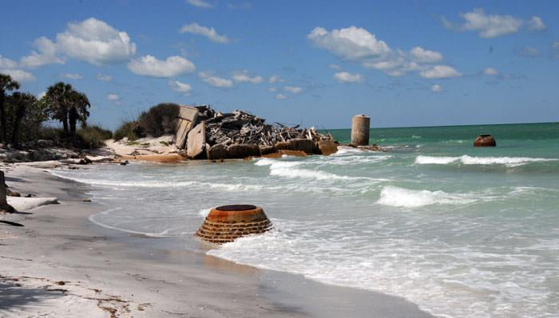
Safety first and foremost!
Does your managing agency already have a disaster plan? Does this plan consider or include cultural resources protective and response measures? If not, take these steps:
- Identify important landscape features:
  - The known record: types of historic properties (submerged and terrestrial archaeological sites, historic structures and buildings, tribal, cultural or historic landscapes, traditional cultural properties, and locations possessing religious and/or cultural significance to communities).
  - Past and/or ongoing archaeological, historic, and ethnographic investigations used to identify significant properties and communities that have cultural connections to specific properties, landscapes, or exploitation and/or extraction of resources (fisheries, plants, etc.).
- Once constituent communities (both indigenous and later post-contact groups) have been identified, managers need to foster personal connections with these communities. Improved and honest communication facilitates improved identification and, ultimately management, of important and/or significant historic properties. It enables managers to identify individuals and/or community organizations that can be drawn upon during the planning process and the subsequent response.
- Identify qualified individuals (staff or local community) that can be drawn upon following the disaster to assess and document impacts to known historic properties and document newly identified features and/or historic properties and their settings.
Plan components:
- Pre-disaster preparation and activities;
- Post-disaster response (assessment of impacts to known historic properties; identification, documentation, and assessment of impacts to newly discovered features and/or properties);
- Remedial actions needed to protect a historic property, minimize and/or mitigate adverse impacts. Such actions will depend upon property type, location, extent of damage, and community input and involvement. Mitigation and resiliency planning is now a major part of this. Funds for planning on non-federal lands are available through FEMA’s Hazard Mitigation Grant Program (HMGP), as well as resources to plan for the securing and protection of vital data and resources prior to and during the response to disasters.
No plan will cover every eventuality. Flexibility is imperative, as is knowing and working with the various communities who consider these historic properties, landscapes, and places as integral to their identity and livelihood.

Engagement Outreach & Interpretation
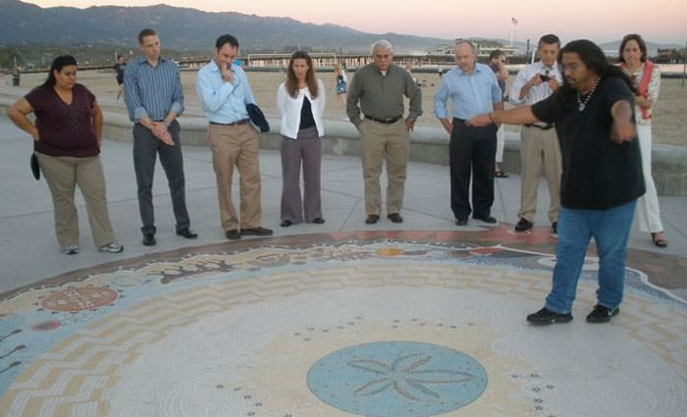Chumash interpreter telling the story of Syuxtun Story Circle in Santa Barbara, CA. (NOAA ONMS)

Stakeholder engagement refers to a variety of ways in which protected area managers reach out to those interested in or affected by protected area management to inform and involve them in management issues. Engagement can be thought of along a spectrum of involvement, from simple awareness to active participation in management activities (such as through citizen science). Examples of engagement strategies include:
- Communication (e.g., media, social media, websites)
- Signage
- Experiential activities (e.g. guided snorkeling or dive trips; other field trips)
- Advisory bodies (e.g., Sanctuary Advisory Councils)
- Community volunteers (e.g. volunteer docents)
- Citizen science (e.g., volunteer monitoring)
- "Friends of.." groups
Opportunities and Obligations
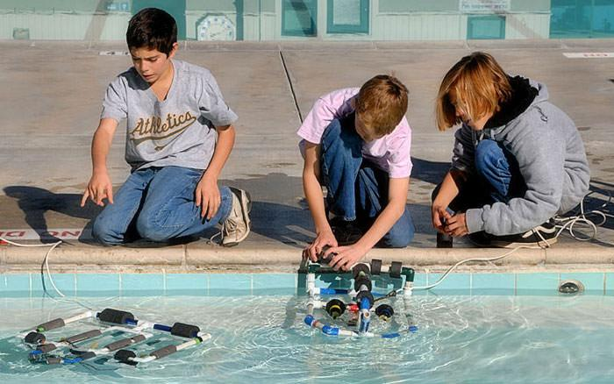Building remotely operated vehicles (ROVs) with students is a great way to introduce cultural resources in MPAs, as well as marine technology career paths. (NOAA ONMS)

Engaging with stakeholders is a critical element of successful management of protected areas. Managers engage stakeholders for a wide variety of reasons, from raising awareness about the existence or conservation goals of an MPA to recruiting volunteers and citizen scientists. Managers of marine cultural resources have a special opportunity when engaging the public, as these resources have the potential to capture the imagination and connect people to their heritage. Key objectives for engaging stakeholders include:
- Increase awareness and raise visibility of the MPA
- Enhance understanding and support for the MPA's purpose and resources
- Sustain formal and/or informal communication and collaboration with community members
- Encourage stewardship behaviors
- Enable others to help advance MPA objectives
- Instill community ownership and pride in the MPA

Methods and Approaches
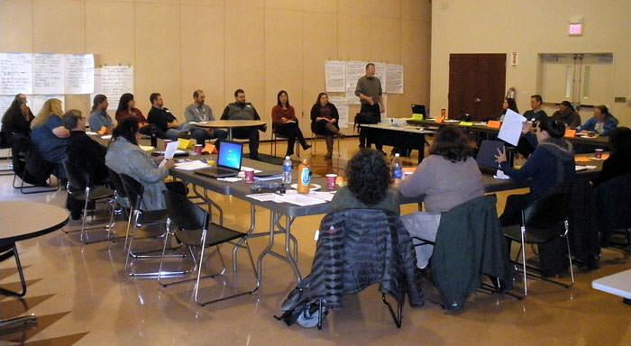Public meetings and advisory bodies enable constituents to play an active role in MPA management. (NOAA ONMS)
A handbook developed by the University of Michigan in collaboration with NOAA Marine Protected Areas Center, Engaging Communities in Marine Protected Areas (PDF) describes principles for MPA managers in engaging communities:
- be proactive
- be clear about purposes and terms
- understand, validate and speak to the community's concerns
- start early, with clear expectations
- be responsive
- be inclusive
- build on common needs and goals
- recognize that it all begins with relationships
Related Topics
Tribal consultation is a formal means of communication between federal agencies and the government of a federally-recognized tribe that reflects the United States' recognition of the sovereignty of federally-recognized tribes. This process is used to exchange information, deliberate, and address federal policies that have tribal implications. As such, this process is distinct from stakeholder engagement, and entails unique legal issues. In many coastal areas, original tribes continue to live in their traditional homelands and are state-recognized, but not federally-recognized. While the obligation to have formal consultation refers only to federally-recognized tribes, federal agencies may find it productive to enter into informal consultative relationship with non-federally recognized tribes and tribal communities who continue to carry multi-generational knowledge of their cultural landscapes. For guidance regarding indigenous peoples, which includes non-federally recognized tribes, see United Nations Declaration on the Rights of Indigenous Peoples.
NOAA Procedures for Government to Government Consultation with Federally Recognized Tribes
Case Studies
38th Voyage of Whaleship Charles W. Morgan
The Chincoteague Wreck Tagging Program

Community-based Tools for U.S. Marine Protected Area Planning and Management

Integrating Cultural Resources into MPA Management
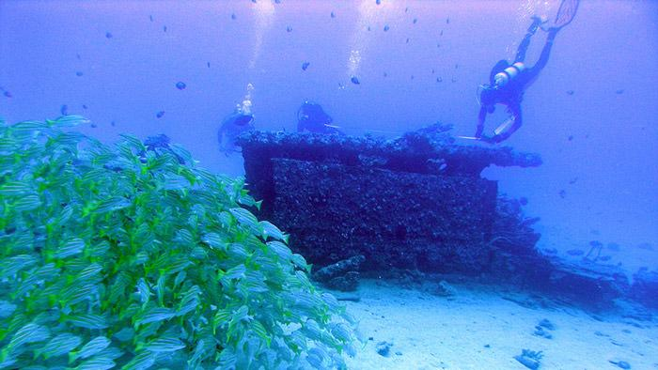Submerged cultural resources and the natural environment are intimately related, as evident between the striped snapper and this WWII amphibious landing craft.

At the most basic level, cultural heritage resources within MPAs consist of those tangible and intangible resources that connect us to the environment. Shipwrecks are a primary example of these heritage resources, for vessels of many shapes and sizes are the ubiquitous platform for human experience on the water. The interpretation of wreck sites reveals much about the activities of past seafarers, their ports of call, their cargos, and the nautical technology of the vessel itself. But consider the seascape of the sailor; it's more than just the ship. Anchorages, wharves, navigational aids, lighthouses, channels, harbors and port facilities all capture elements of the past, the remains of which can often be found underwater. And consider the more direct relationship of mariners from the longer pre-industrial age. Canoe construction areas, bays and landings, navigation landmarks, traditional fishing and gathering locations, and the customary knowledge of these places are all intangible elements which preserve the same cultural heritage, even though that knowledge is not focused on a physical property per se. All of these tangible and intangible assets or resources are elements of the maritime cultural landscape. When perceived and understood, they can speak of important past and present human activities, and connections to the marine environment that maintain our cultural identity and life-ways.
Opportunities and Obligations
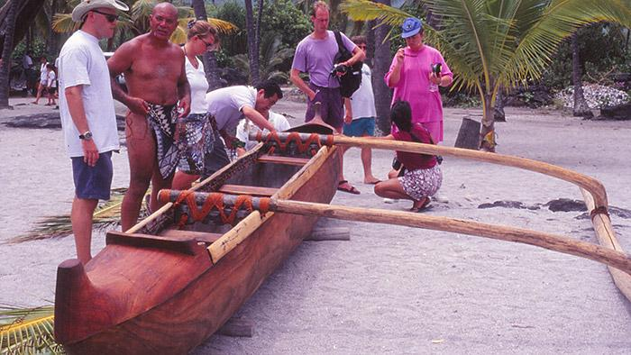Marine areas may be significant sites of traditional practices such as canoe launching areas.

Maintaining healthy coastal and marine ecosystems requires a fundamental understanding of the relationships between people and the environment. Adopting a cultural landscape approach can help managers achieve this understanding, as well as engaging new audiences in support of marine conservation goals. A cultural landscape is a place where the intersection of culture and nature leaves a distinct ecological or cultural imprint. A cultural landscape approach is an analytical framework for understanding the ways in which specific cultural and environmental processes overlap and influence one another. In many ways, a cultural landscape approach is analogous to ecosystem-based management – it is a holistic way of looking at places, people and how they form and change one another.
Many protected area managers lack training and knowledge of cultural resource management. As a result, these resources are sometimes either neglected or are managed by cultural resource experts separately from other MPA resources. Moreover, traditional approaches to the management of cultural resources, such as shipwrecks and archeological sites, typically studied and managed these sites individually. A cultural landscape approach can help identify ecological and cultural connections among different sites, resources and protected areas over time.
Methods and Approaches
This section will help you understand how to identify cultural resources within your MPA, and how to integrate these resources into your MPA management plan. Managers do not have to "reinvent the wheel" in order to protect important cultural heritage resources, for more sites every year are gaining experience in cultural resource management. Here are seven basic steps in initiating cultural resource management in your MPA.
1. Develop the important cultural landscape contexts for your MPA, being sure to include the human and ecological history of your site.
The Cultural Landscape Approach provides the necessary contextual background to fully understand the local cultural setting and be able to identify important heritage resources at your site. Cultural Landscapes are the intersection of both human activities and environment, so information from both the natural/ecological and cultural/historical perspectives must be included. For further guidance see: A Cultural Landscape Approach
2. Identify the principal types of cultural resources likely to be in your MPA.
What types of cultural resources exist in my site? Every site possesses a variety of tangible and intangible cultural resources, important touchstones and waypoints connected to human history, which are of significance to multiple groups. See What are Cultural Resources for a list of examples of types of cultural resources.
3. Identify contemporary stakeholders and constituents with important heritage connections to associated CHR within your MPA.
Cultural resource management is not just about the site or artifact itself, but focuses instead on the human cultural connections that exist in, or are expressed through, your MPA. Creating a positive working relationship with those individuals and groups who have inherent cultural connections to your MPA may be the single most important step a successful site manager can take. For further guidance see: Engagement Outreach & Interpretation
4. Identify local tribes and indigenous peoples with connections to your MPA.
In general, many tribal and indigenous people have been intensely engaged with marine cultural resources for many generations, and may already benefit from established traditional forms of resource management. For further guidance see: Tribal and Indigenous Communities
5. Identify the primary statutory responsibilities for cultural resource management and protection within your MPA.
As a manager, you are responsible for understanding and implementing federal and state heritage preservation mandates and other laws that address cultural resources. Furthermore, state and federal agencies have specific obligations to many indigenous and tribal groups. For further guidance see: Legal Authorities
6. Identify available in-house or collaborative capacity for cultural resource management and recognition.
Most MPA managers face capacity and budget constraints and so are often "moving towards" rather than "completing" conservation and preservation goals. It is important to seek partners and shared capacity in this specialized field of maritime cultural resource management.Several excellent programs and organizations can provide specific training and assistance. Local educational institutions and societies likely have contextual information. Seeking local researchers and others in this exciting field is a great way to engage the public in your MPA.
7. Incorporate cultural heritage resources management and preservation into your MPA management plan.
With the proper background information, identification of resources, capacity and collaborating partnerships, and an understanding of your MPA's legal responsibilities, you are now in the position to make cultural resource management and preservation a valued part of your formal site management plan. Like any other site resource, this will entail understanding the potential benefits of public outreach and education, the fundamentals of data collection and monitoring and evaluation, handling of potentially sensitive information, and the potential (or real) threats to the resource, such as human impacts and environmental forces. While specific cultural resource strategies and activities may be consolidated in an individual chapter or sub-plan, the cultural landscape approach highlights the fact that cultural influences are part of every management decision for MPAs.
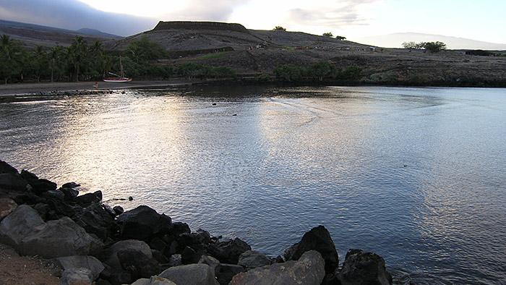Viewsheds often have cultural significance. The National Historic Site of Pu`ukoholā Heiau (temple) on the Island of Hawai`i overlooks Hale o Kapuni (submerged) in Pelekane Bay, a site once dedicated to sharks.

Intellectual Property and Sensitive Information
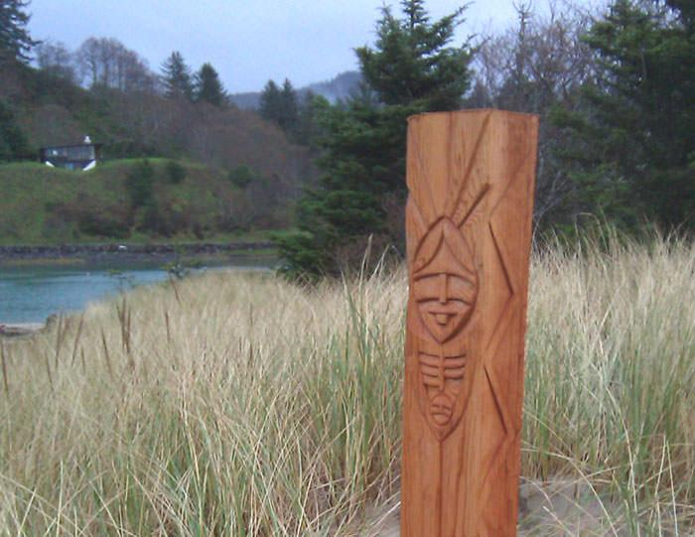Memorial Post at the mouth of the Salmon River, to honor the Neschesne people and the village that stood there. Carved by Grand Ronde artist, Travis Stewart. (Travis Stewart)

MPA managers are responsible for the protection of sensitive information and intellectual property. Disclosure of information such as site location, ownership data, and site characteristics has the potential to jeopardize cultural resources. Legal mechanisms such as the Archaeological Resources Protection Act (ARPA), the National Historic Preservation Act (NHPA), and the Freedom of Information Act (FOIA) provide protections for sensitive information.
Intellectual Property (IP) refers to creations of the human mind and IP rights protect the rights of creators over their creations. IP is generally understood within the framework of the Western legal system and concepts of individual property. Legal mechanisms are available to protect IP such as copyrights, trademarks, patents, and trade secrets. However, these mechanisms are often insufficient for protecting collective or community-based IP which is created and maintained through a transgenerational process of information exchange and "owned" by the community rather than by individuals. This type of IP is prevalent within the realm of cultural resources management. Some examples include art, language, symbols, music, oral narratives, and traditional knowledge.
Responsible cultural resources management requires a comprehensive understanding of where IP rights and sensitive information may be at risk and the mechanisms available for protecting both tangible and intangible forms of information, knowledge, and cultural expressions.

Opportunities and Obligations
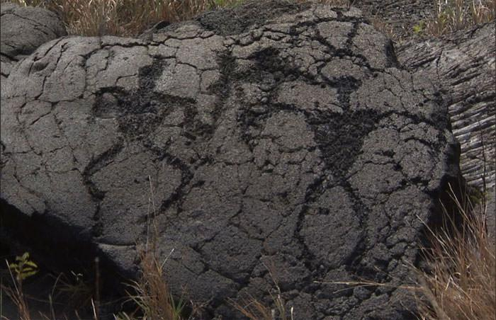Various aspects of cultural resources may constitute sensitive information, including their technique, location, and/or significance. (NOAA ONMS)

An awareness of IP and sensitive information reinforces a sound conservation ethic and supports compliance with federal mandates, customary laws, and international conventions. MPA managers face tensions between their public education requirements and issues of confidentiality, resource or stakeholder protection, and tribal rights protection. Inappropriate use or release of information and knowledge can inflict harm on both resources and people. For example, disclosure of site location may lead to vandalism, and release of information on traditional practices may jeopardize a community's ability to conduct such practices, or result in exploitation of tribal culture. International conventions exist to protect indigenous peoples and traditional knowledges from exploitation.
By virtue of their role as stewards of our cultural and natural resources, MPA managers must be diligent in the area of information management. In recent years, cultural heritage management has evolved to encompass relationships between cultural landscapes and related information, knowledge and cultural expressions, resulting in expanded protection of information beyond simple sight locations. Much of this work is grounded in evolving concepts of IP and sensitive information management. Successful resource management requires support from various stakeholders such as tribal communities, fishers, divers, academics, landowners, etc. Poor or careless information management can jeopardize relationships between MPA managers and stakeholders. Strategies that acknowledge the IP rights and contributions of stakeholders foster good relations and enrich MPAs by way of enhanced data, improved management techniques, and shared stewardship.
Methods and Approaches
Wabanaki baskets. (Bonnie Newsom)

Sound IP and sensitive information protection and management strategies are multi-faceted and should blend legal and non-legal approaches. An effective strategy for addressing IP and sensitive information issues is a management plan that incorporates mechanisms for preventing IP rights violations and provides procedures to protect sensitive information against compromise. An ongoing tribal consultation and community engagement agenda is essential to this approach. Through this process, management can support equitable terms of research, guidance, and policies that address both tangible and intangible cultural heritage. Protocols and agreements can be useful tools in defining how information and knowledge is used, controlled and accessed, to the benefit of all stakeholders.
Management should also have a firm understanding of legal mechanisms available for protecting and managing IP and sensitive information. Legal tools such as copyrights, trademarks, and patents can serve to protect IP. However, these laws have limited applicability for community-based or collectively-owned knowledges. Additionally, federal laws such as ARPA, NHPA and FOIA are useful tools for protecting sensitive information in the federal arena. Each offers specific protections for categories of cultural resources-related information such as site location or ownership data.

Research, Monitoring and Evaluation
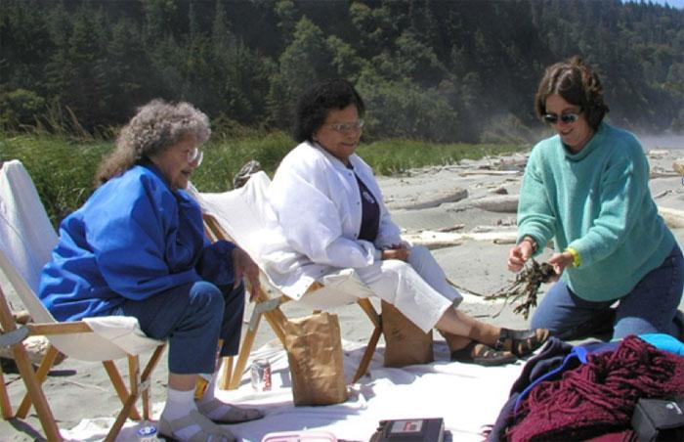Tribal members share information about nearshore traditional resources in 2003 at Crescent Bay, Olympic National Park, WA. (Jacilee Wray)

Effectively recognizing and understanding cultural resources within a management area can be achieved through community engagement, research and data collection. Submerged archaeological sites, as part of a region's maritime cultural landscape, can be a reflection of international, national, regional, or localized habitation, commerce, industry, immigration, transportation, naval actions, and sacred areas. Researching the cultural history of an area and the interconnections between water- and land-based human activity can elucidate both broad historic patterns and specific activities that may help identify and contextualize individual archaeological sites or culturally sensitive areas.
Archaeological data collection augments research through diver reconnaissance or the use of specialized remote-sensing equipment to locate and study submerged sites. Newly-discovered cultural resources should be inventoried and investigated to compile baseline data regarding their location, extent, condition, age, purpose, identity (in the case of vessel remains), and cultural affiliation. Cultural heritage research also involves sociocultural, socioeconomic, and political variables of the communities. Ethnographic and other social scientific research is typically used to understand the these dimensions of MPA use, especially where native peoples are involved. The primary techniques for acquiring ethnographic data are through observation and interviews.
Periodic monitoring should be implemented to understand and track changes and impacts over time, especially in regions that experience regular industrial expansion, recreational activities, and/or consistent marine traffic.
Opportunities and Obligations
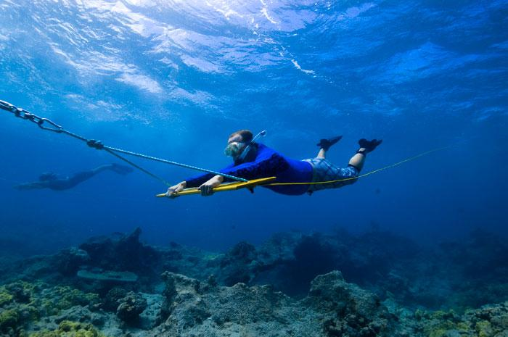NOAA archaeologists use towboards to search for shipwrecks such as the British whaler Gledstanes in the Papahanaumokuakea Marine National Monument. (NOAA ONMS)

Developing research to build data sets for historical context and reported sites can aid in understanding and identifying an area's cultural resources and is a crucial step in detection and preservation. Data collection is part of the discovery effort and can also define areas that are not cultural sites. Knowledge of both site presence and absence is important in developing contextual information for defining culturally sensitive areas. Data collection is instrumental in recording discovered sites, their attributes, history, location, and condition. Criteria outlined in the National Register of Historic Places can be used to help determine significance, and may also be augmented by other additional designations at the state level that can aid in long-term preservation of sites.
Monitoring is the most effective method for studying changes to a submerged site over the course of its lifetime. Impacts, both natural and man-made, constitute what is referred to as a site's "formation processes." Systematic monitoring can potentially identify the factors that influence a site's degradation so that preventative measures can be implemented.
By understanding the local sociocultural and socioeconomic context in which marine resources are used, planning and programming for conservation can be achieved through stakeholder engagement. A number of critical socioeconomic and cultural indicators are often measured, analyzed, and monitored.
Methods and Approaches
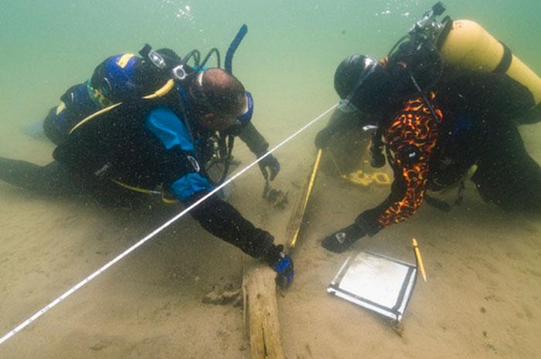Training and collaborating with volunteer stewards can be crucial for collecting data, and serve a dual purpose for public outreach and education. (NOAA ONMS)

Developing historic, ethnographic, and archaeological contexts involves research, database management, and effective file management. Geospatial databases, such as ArcGIS, are invaluable tools for creating summary research files that can include diverse and extensive information. Developing such data sets and the related research can be time consuming and sometimes outside of the scope of existing responsibilities. In such cases utilizing volunteer stewards and interns can be crucial for assimilating data, and serves a dual purpose for public outreach and education.
Archaeological data collection and monitoring will vary based on the geophysical setting of the site. Attributes such as visibility, depth, salinity, temperature, and associated biota all affect site preservation and protection potential. Data collection and monitoring is effected through remote-sensing survey methods as well as dive investigations and mapping.
Data collection and analysis of sociocultural and socioeconomic phenomena may involve both quantitative and qualitative methods, including direct or participatory observation, open-ended interviews, semi-structured interviews, and focus groups.
The evaluation of cultural resources can include federal and/or state designations of significance, including the framework established by the National Historic Preservation Act and its supplemental bulletins that offer additional guidance for specialized topics. For assistance in National Register nominations, and to learn of individual state designations, please contact your State Historic Preservation Officer.
Case Studies
Texas Historical Commission's Research, Monitoring, and Evaluation Efforts

Resources
A Cultural Landscape Approach
Native American Traditional Cultural Landscapes Action Plan (Advisory Council on Historic Preservation (ACHP), 2011)
Cultural Landscapes Inventory Professional Procedures Guide. (National Park Service, 2009)
Characterizing Maritime Cultural Landscapes from First Principles: Cultural Landscape Approaches and Maritime Cultural Landscapes. Valerie Grussing, Delivered at the Maritime Cultural Landscape Symposium, Oct. 14-15 University of Madison-Wisconsin.
The Unseen Landscape: Inventory and Assessment of Submerged Cultural Resources in Hawai`i (BOEM, 2017)
The Maritime Cultural Landscape. (Westerdahl, Christer, 1992) International Journal of Nautical Archaeology 21.1: 5-14.

Legal Framework
Federal Submerged Cultural Resource Laws
Submerged Cultural Resource Laws by State
Research
Monitoring Guidelines (New York Archaeological Council)
Developing Archaeological Site Stewardship Programs (National Park Service)
Descent into Darkness – Exploring Gulf of Mexico Shipwrecks

National Register of Historic Places
National Register of Historic Places
Nominating Historic Vessels and Shipwrecks to the National Register (National Park Service)
How to Complete the Nation Register Registration Form (National Park Service, 1997)

Climate Change

MPA Center Climate webpage
Climate Change and Stewardship of Cultural Resources Policy (National Park Service Memorandum, Feb. 2014).
Climate Change Response Program Cultural Resource Brief (National Park Service, March 2013)
Cultural Resources Climate Change Strategies. National Park Service, 2016
Cultural Resources Impacts Table. National Park Service, 2016
Tribal/Indigenous Resources
Guidelines for Native American Monitors/Consultants (Native American Heritage Commission)
A Guidance Document for Characterizing Tribal Cultural Landscapes (BOEM, 2015).
A Guidance Document for Characterizing Native Hawaiian Cultural Landscapes (BOEM, 2017).
Consultation with Indian Tribes in the Section 106 Review Process: a Handbook. (Advisory Council on Historic Preservation, ACHP, 2008).
Developing Protocols for Reconstructing Submerged Paleocultural Landscapes and Identifying Ancient Native American Archaeological Sites in Submerged Environments: Best Practices (BOEM 2018).
NOAA Procedures for Government to Government Consultation with Federally Recognized Tribes
A `Ikena I Kai (Seaward Viewsheds): Inventory of Terrestrial Properties for Assessment of Marine Viewsheds on the Main Eight Hawaiian Islands (BOEM, 2017)

A Guidance Document for Characterizing Native Hawaiian Cultural Landscapes (BOEM, 2017)

Underwater Archeology

Nautical Archaeology Society
American Academy of Underwater Sciences
Advisory Council on Underwater Archaeology
Maritime Archaeological and Historical Society
NOAA Maritime Heritage Program
National Park Service Submerged Resources Center
Florida Public Archaeology Network

Intellectual Property
Indigenous Peoples and Intellectual Property (Graham and McJohn, Washington University Journal of Law and Policy, January 2005).

Seeking consent for research with indigenous communities: a systematic review, BMC Med Ethics. 2016; 17: 65.
(See also resources under Outreach)

Glossary
Archaeological data collection: Coastal geography and water conditions can make discovery of cultural resources challenging; a diverse array of field methods have been developed and refined over the years to increase detection.

Climate Smart Conservation principles were created by the National WIldlife Federation help practitioners and policy-makers how to develop and implement conservation that understands climate and climate change. The four overarching principles include:
- Act with intentionality through linking actions to impacts
- Manage for change, not just persistence
- Reconsider goals, not just strategies
- Integrate adaptation into existing work
A cultural landscape is a place where the intersection of culture and nature leaves a distinct ecological or cultural imprint.
Cultural Landscape Approach: an analytical framework for understanding the ways in which specific cultural and environmental processes overlap and influence one another. In many ways, a cultural landscape approach is analogous to ecosystem-based management – it is a holistic way of looking at places, people and how they form and change one another. This approach can help identify ecological and cultural connections among different sites, resources and protected areas over time.

Cultural Resources are related to cultural identity, such as religious, food and burial practices. These resources may also be nautical (related to ships, vessels and watercraft) and/or maritime (related to human seafaring). (See “What Are Cultural Resources?”)

Data collection and analysis of sociocultural and socioeconomic phenomena may involve both quantitative and qualitative methods, including direct or participatory observation, open-ended interviews, semi-structured interviews, and focus groups. Quantitative data is typically collected through household socioeconomic surveys. In addition, qualitative data may be gathered in recorded interviews through note-taking or using either video or voice recorders. Cognitive Anthropological studies typically focus on cultural domains. The methods used to collect systematic data for these analyses include free lists, sentence frames, triad tests, pile sorts, and paired comparisons. More advanced methods may involve componential analysis, folk taxonomies, and ethnographic decision model.

Ethnographic and other social scientific research typically involves the observation of and interaction with persons or a group being studied in the group's own environment, often for long periods of time. It is the systematic study of people and living cultures, and is designed to explore cultural phenomena where the researcher observes society from the point of view of the subject of the study. An ethnography is a means to represent graphically and in writing the culture of a group. The resulting field study or a case report reflects the knowledge and the system of meanings in the lives of a cultural group. An ethnography records all observed behavior and describes all symbol-meaning relations, using concepts that avoid causal explanations.

Ethnohistorical is the study of cultures and indigenous peoples' customs by examining historical records as well as written documents, oral narrative, material culture, and ethnographic data.

Heritage sites are places containing historic and prehistoric cultural resources, are of inherent value to the people and cultures connected to them, and have scientific value as repositories of historical ecological data.
Impacts, both natural and human-made: Examples of naturally occurring events that can alter a submerged site include storm activities, scouring, erosion, burial, and habitat creation. Human-made impacts can be severe and encompass diver-related artifact recovery, vessel collision, fishing, pollution, salvage, navigation obstruction removal, and construction activities such as channel dredging.

Intellectual Property (IP) refers to creations of the human mind and IP rights protect the rights of creators over their creations.

Marine Protected Area means means any area of the marine environment that has been reserved by Federal, State, territorial, tribal, or local laws or regulations to provide
lasting protection for part or all of the natural and cultural resources therein (Executive Order 13158).

Maritime heritage is the wide variety of tangible and intangible elements (archaeological, cultural, historical) which represent our human connections to our Great Lakes and ocean areas.

Maritime heritage resources are those elements of our connection to our Great Lakes and ocean areas that should be preserved for future generations.

“No Regret" Strategies are those that will benefit the site and potentially other sectors, regardless of climate impacts. These are also strategies that will not divert resources away from other priorities because they have a low to medium cost of implementation.

Remote-sensing surveys are the standard means for detecting new sites, and these typically utilize a magnetometer (detects ferrous metal) and side-scan sonar, the latter of which produces a sonar image akin to a photographic record. A sub-bottom profiler can also be used, which records submerged geophysical attributes such as geological strata river channels and can also detect buried structures. Other enhanced imagery collection instrumentation includes sector-scan, multi-beam, and BlueView sonar acquisition systems.

Sensitive information refers to information that has the potential to jeopardize cultural resources such as site location, ownership data, and site characteristics.
Site attributes affecting preservation and protection potential: High visibility marine environments present greater ease in detection, investigation, and monitoring but can also present greater challenges in protection and preservation. Inversely, sites in low visibility or backwater environments can be difficult to detect and monitor but are afforded perhaps greater protection as the environment indirectly conceals them. Saltwater shipwreck sites, through consumption by the shipworm (teredo navalis), can be largely degraded or semi-buried whereas freshwater sites typically have better preservation and can be more recognizable as an archaeological site.

Socioeconomic and cultural indicators are often measured, analyzed, and monitored. Examples include: local marine resource use patterns, local values and beliefs about marine resources, level of understanding of human impacts to resources, perceptions of seafood availability, perceptions of local resource harvest, perceptions of non-market and non-use value, material style of life, quality of human health, household income distribution by source, household occupational structure, community infrastructure and business, number and nature of markets, stakeholder knowledge of natural history, distribution of formal knowledge to community, percentage of stakeholder group in leadership positions, and changes in conditions of ancestral and historical sites/features/monuments.

Stakeholder engagement refers to the variety of ways in which protected area managers reach out to those interested in or affected by protected area management to inform and involve them in management issues.

Tribal consultation is a formal means of communication between federal agencies and the government of a federally-recognized tribe that reflects the United States' recognition of the sovereignty of federally-recognized tribes. This process is used to exchange information, deliberate, and address federal policies that have tribal implications. As such, this process is distinct from stakeholder engagement, and entails unique legal issues.
Traditional ecological knowledge, also called by other names including Indigenous Knowledge or Native Science (TEK), refers to the evolving knowledge acquired by indigenous and local peoples over hundreds or thousands of years through direct contact with the environment. This knowledge is specific to a location and includes the relationships between plants, animals, natural phenomena, landscapes and timing of events that are used for lifeways, including but not limited to hunting, fishing, trapping, agriculture, and forestry. TEK is an accumulating body of knowledge, practice, and belief, evolving by adaptive processes and handed down through generations by cultural transmission, about the relationship of living beings (human and nonhuman) with one another and with the environment. It encompasses the world view of indigenous people which includes ecology, spirituality, human and animal relationships, and more.
Vulnerability assessment is a way to evaluate the implications of climate change for the habitats of marine protected areas, allowing managers to engage with science and encourage the creation of adaptation strategies to reduce the vulnerabilities identified. It can be modified to assess the vulnerability of any aspect of mpa management.

